**Assignment 6: Synopsis for your mini project**

**Grocery Store Management System**

**Mis: 111903099 Division: 2**

**Name: Shreya Kolkur Subject: DBMS**

**Github link : https://github.com/Shreya-Kolkur/DBMS-Project.git**

1. **Relational schemas obtained from ER.**

**admin**

|  |  |  |
| --- | --- | --- |
| **username** | name | password |
| shreya | Shreya | shreya |

**employee**

|  |  |  |  |  |  |
| --- | --- | --- | --- | --- | --- |
| **employee_id** | name | date_of_joining | contact_no | password | Managed_by |
| 1 | Abc | 1/1/2001 | 789456123 | 12345 | shreya |
| 2 | jkl | 1/2/2002 | 123456789 | 12345 | shreya |

**products**

|  |  |  |  |  |  |
| --- | --- | --- | --- | --- | --- |
| **product_id** | prod_name | stock | price | catg | Updated_by |
| 12 | parle | 40 | 20 | biscuit | shreya |

**bill**

|  |  |  |  |  |  |
| --- | --- | --- | --- | --- | --- |
| **bill_no** | cust_name | cont_no | date | tot_price | Employ |
| 25 | pol | 456789123 | 4/2/2020 | 65 | 1 |

**orders**

|  |  |  |  |  |  |
| --- | --- | --- | --- | --- | --- |
| **Order_id** | Product_id | No_of_items | date | tot_price | Placed_by |
| 1 | 12 | 10 | 4/2/2020 | 85 | shreya |

**2.Set of functional dependencies that must hold on each table.**

**admin**

username -> password

username -> name

**employee**

employee_id -> name

employee_id -> password

employee_id ->date_of_joining

employee_id -> cont_no

employee_id -> managed_by

**products**

product_id -> name

product_id -> price

product_id -> stock

product_id -> catg

product_id -> updated_by

**bill**

bill_no -> employ

bill_no -> cust_name

bill_no -> cont_no

bill_no -> date

bill_no -> tot_price

**orders**

order_id -> product_id

order_id -> tot_price

order_id -> no_of_items

order_id -> date

order_id -> placed_by

1. **ER Diagram**

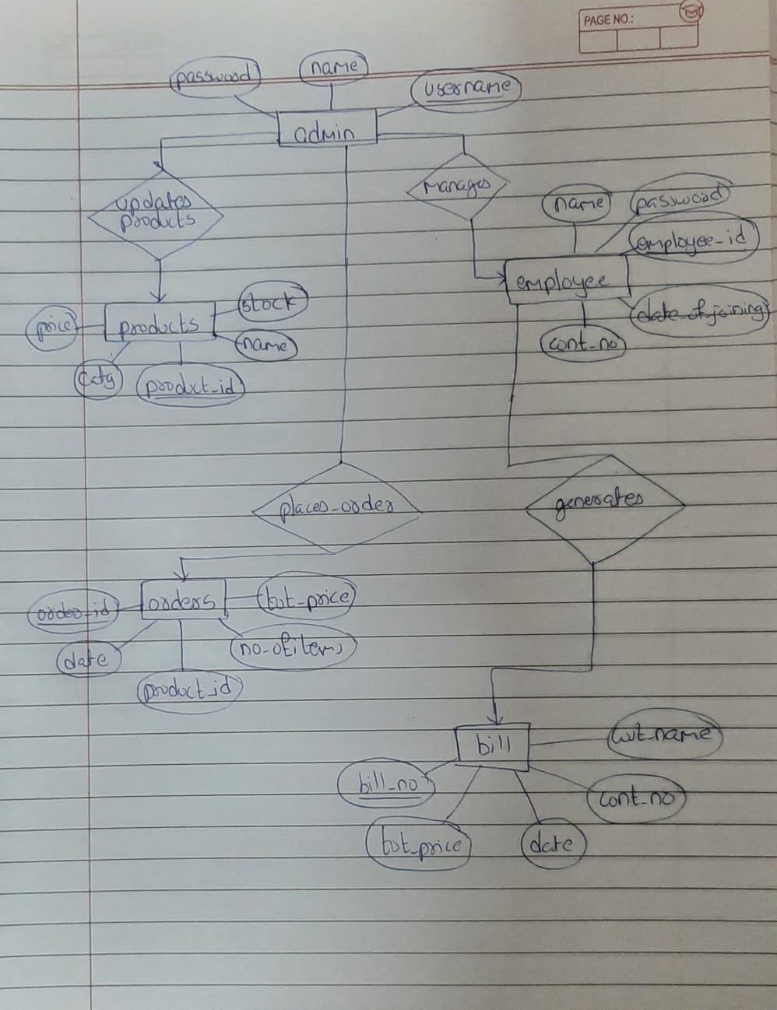

**Schema**

